**CURRICULUM VITAE**

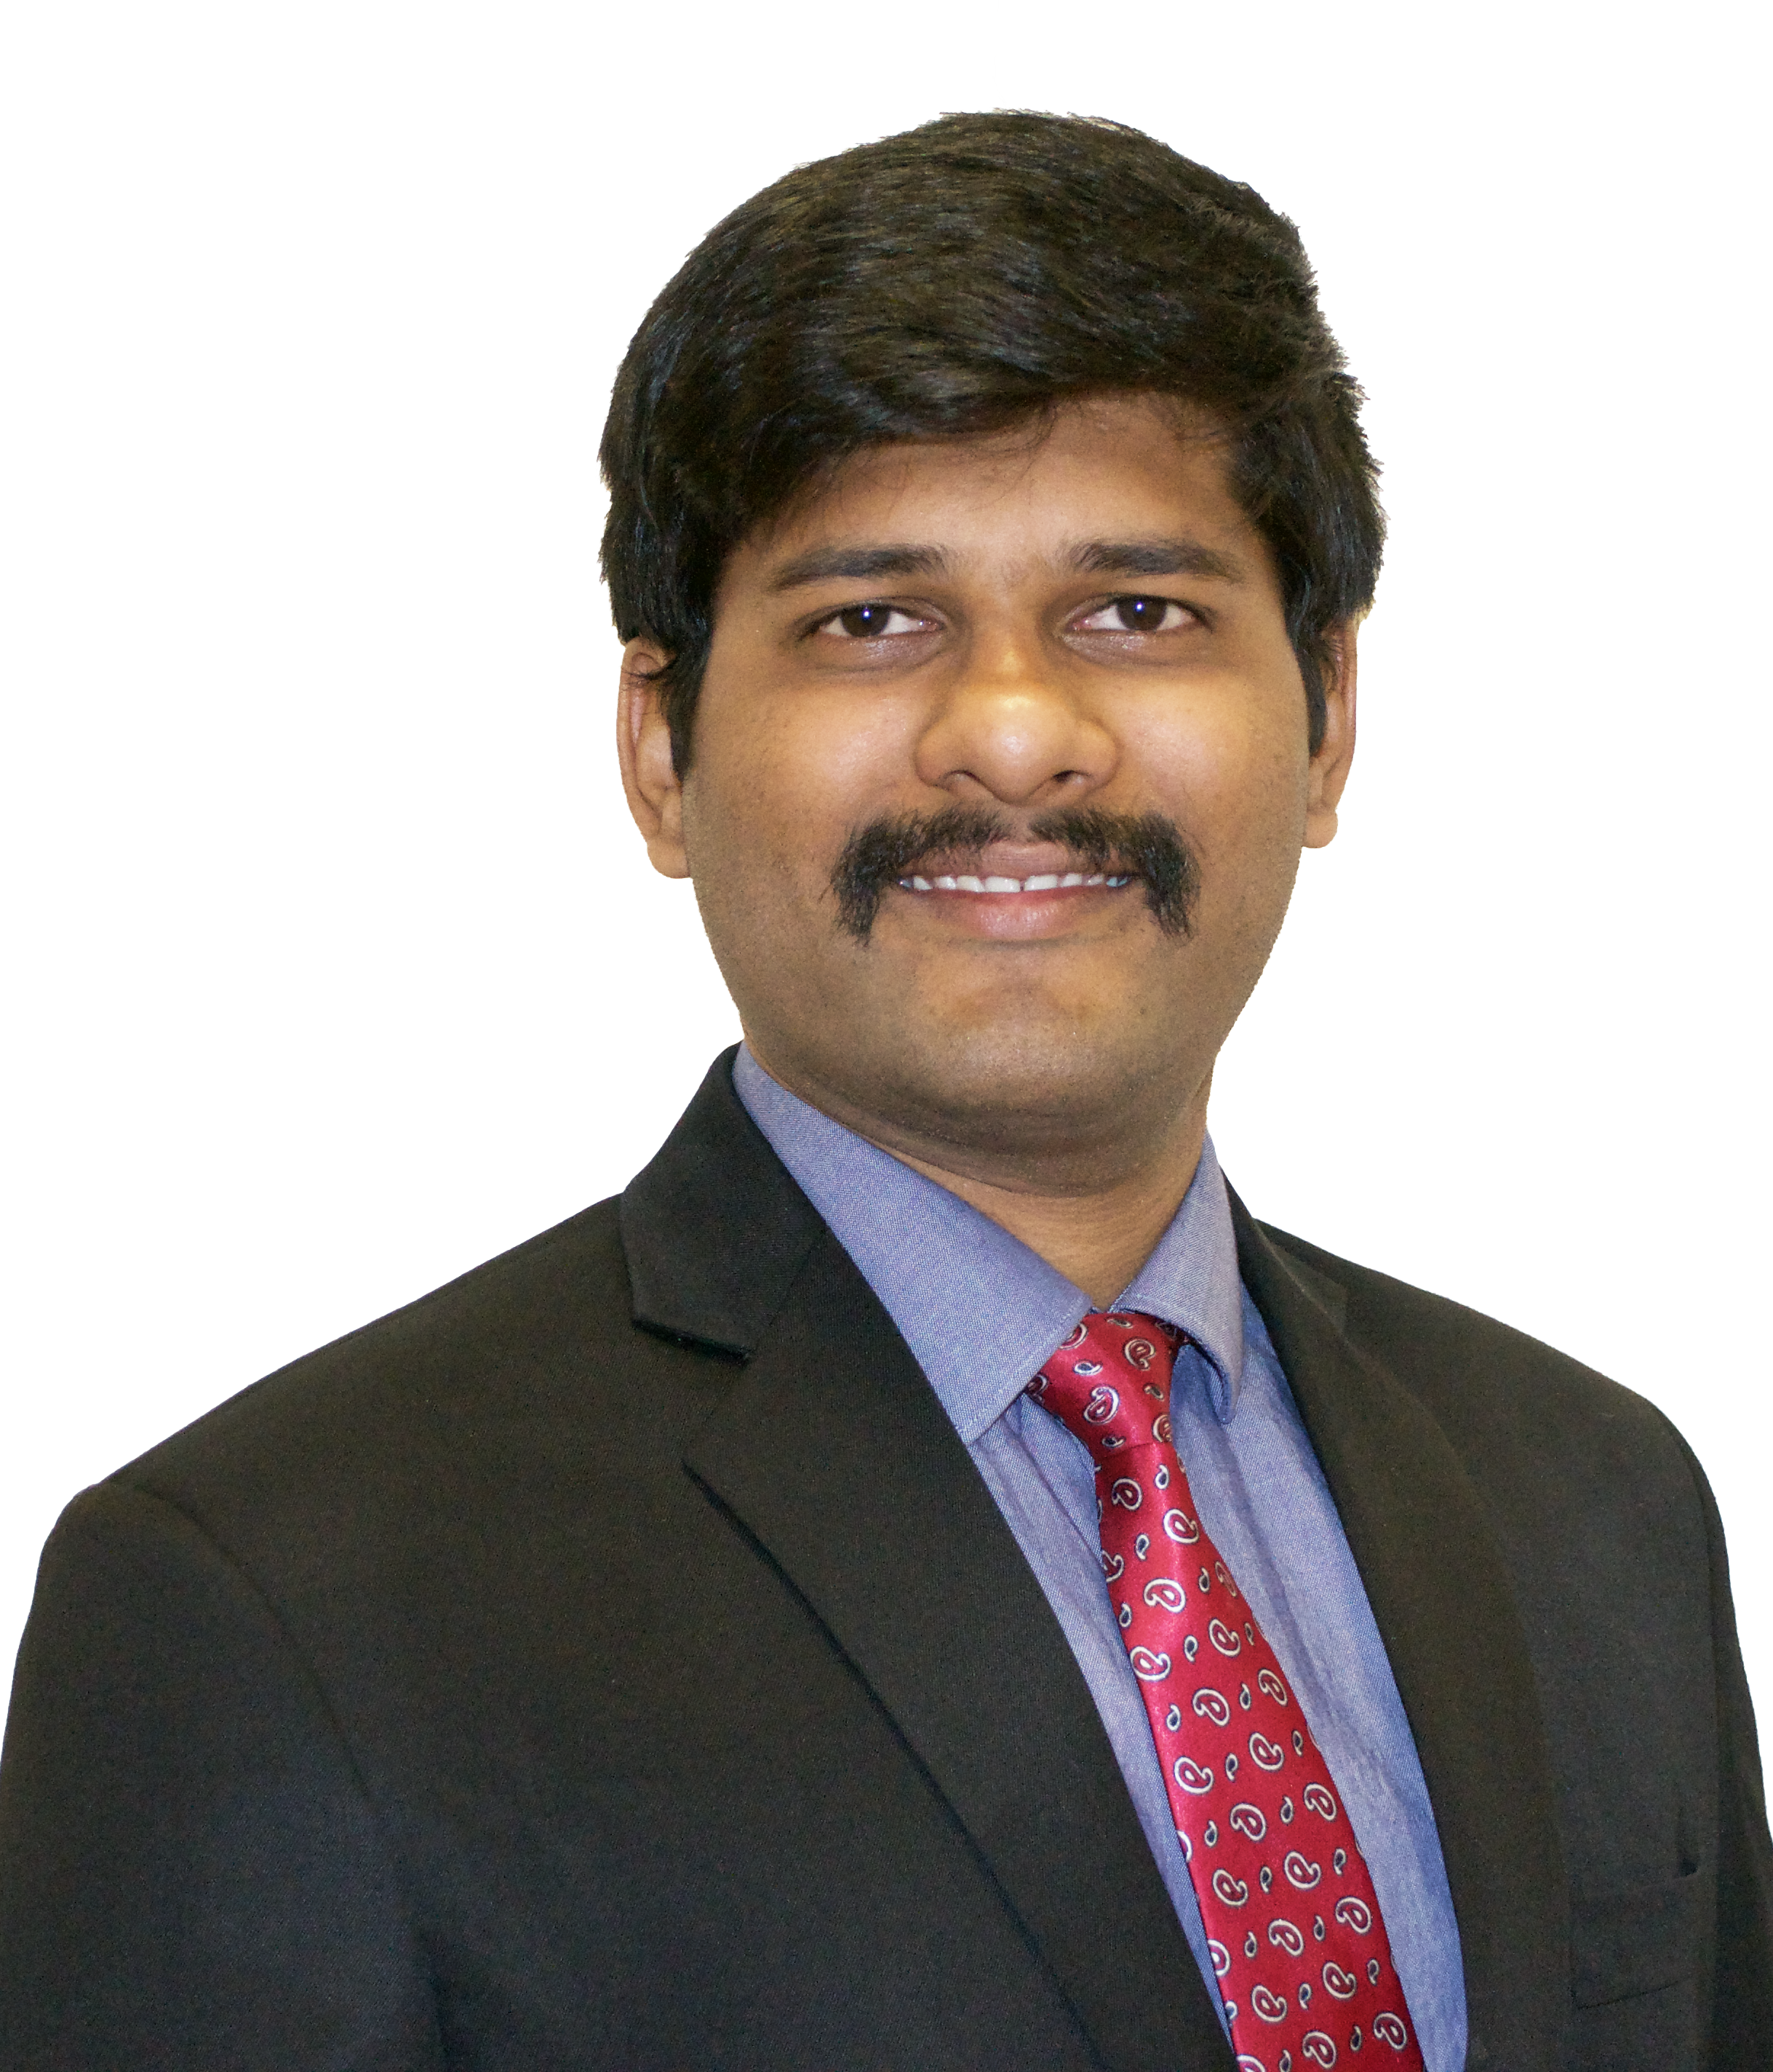**PERSONAL DATA**

Name Jagadeesh Kumar. A  
Phone +49 176 24082328  
Date of Birth 5th January, 1994  
Email ID [jagadeesh.srmuniv@gmail.com](mailto:jagadeesh.srmuniv@gmail.com)  
Address Zugspitzstrasse 80,  
 Vaterstetten – 85591,  
 Germany

**EDUCATIONAL QUALIFICATION**

Masters M.Eng. in Electrical Engineering and Embedded Systems  
09/2016 – 03/2018 (Expected)

Bachelors B.Tech. in Electronics and Instrumentation Engineering  
 06/2011 – 05/2015

**WORK EXPERIENCE**

08/2017 – present **Master’s Thesis** Technical University of Munich  
 Munich, Deutschland.

Title **Hardware Circuit Design for a TDLAS Measurement system**

**Skills and Responsibilities**

To design a PCB hardware circuit for a Tunable Diode Laser Absorption Spectroscopy (TDLAS) between the experimental components (Laser Diode, Photo Diode) and the computer. The functions of the PCB would include:

* Laser and Photo Diode controllers, which are the TEC drivers to keep the the laser and PD at exact temperature.
* P & T sensors: set pressure and temperature sensors in the system, and send the P, T values into the data processing.
* Signal generator: which is used to tune the laser wavelength, and modulate it using the high frequency sine signal.
* Data acquisition: collect the data from the PD and signal generator, send them to the lock-in system in the computer (we have made the lock in system and gas concentration calculation software, some modification may be made to suit the PCB).

08/2015 – 07/2016 **Electronics and Flight Control Engineer** Skylark Drones Pvt. Ltd  
 Bengaluru, India.

**Skills and Responsibilities**

* Integrating and Monitoring electronic sensors on drones.
* Programming and fetching live feed telemetry from the drones during operation.
* Manual Piloting and controlling autonomous navigation of drones for aerial surveillance.
* R&D for different types of Controllers and PID tuning for both fixed wing and Multi-rotor type drones.
* Programming Flight Controller for in-flight operations and recovering the fetched telemetry for post processing.

10/2016 – 02/2017 **System On Chip Designer (Work Student)** HS-Ravensburg Weingarten  
 Weingarten, Deutschland.

**Skills and Responsibilities**

* Designed an 8-Bit Tester Chip and Port Expander PCB using EAGLE CAD.
* Developed VHDL program along with Test Bench for simulating the Tester Chip as it would on a XILINX FPGA.
* Presently working on Development of 8051 Microcontroller using VHDL.
* Realizing Oregano VHDL code of MC8051 into SystemC.

10/2016 – 07/2017 **Embedded Computing Engineer** HS-Ravensburg Weingarten  
 Weingarten, Deutschland.

**Skills and Responsibilities**

* Learnt the architectures of different types of Embedded Systems.
* Programmed Raspberry Pi using OpenCV image Processing to read the distance of an object from the RaspiCam by detecting a QR code attached on the object using Embedded C language.

10/2016 – 07/2017 **Student Assistant** Signal Processing Lab  
 HS-Ravensburg Weingarten  
 Weingarten, Deutschland.

**Skills and Responsibilities**

* Acquired knowledge on designing Analog and Digital Filters for various applications.
* Integrating modern day technologies with Digital Signal Processing Algorithms.
* Realized various complicated Signal Processing circuits using PicoScope and Matlab.
* Helping the R&D department by testing various DSP and Communication Systems.
* Designed various Higher Order Filters and implemented them using the Arduino Due Microcontroller.

11/2016 – 12/2016 **Software Developer (Work Student)** Boehringer Ingelheim  
 Pharma GmbH & Co. KG  
 Biberach, Deutschland.

**Skills and Responsibilities**

* Successfully presented our team’s idea and won first place at the Boehringer eHealth Hackathon.
* Developed a Raspberry Pi based eHealth monitoring system to record and simultaneously upload the feed values from different health sensors such as Blood Pressure, Temperature, Sugar level sensor, etc. to the cloud.

**EDUCATION AND TRAINING**

Dates 09/2016 – 03/2018 (Expected).

Qualification **Master of Engineering in Electrical Engineering and Embedded Systems.**

Organization Hochschule Ravensburg Weingarten, 88250, Weingarten, Deutschland.

Principle Subjects

* Advanced Mathematics Skills: - MATLAB, GNU OCTAVE
* Signal Processing Skills: - MATLAB and Picoscope
* Telecommunication Technology Skills: - Cadence OrCAD, PSpice
* Embedded Computing Skills: - C/C++, Rasberry Pi & Arduino
* System on Chip Skills: - EAGLE, VHDL
* Embedded Control Skills: - MATLAB, Control Systems

Dates 07/2011 – 05/2015

Qualification **Bachelor of Technology in Electronics and Instrumentation Engineering.**

Organization SRM University, 603203, Chennai, India.

Principle Subjects

VLSI Design and Embedded Systems, Virtual Instrumentation, Communication Technology, Advanced Engineering Mathematics, Control Systems, Digital Systems, Digital Signal Processing, Microprocessors and Microcontrollers, Digital System Design, Power Electronics, Electrical Machines, Engineering Mechanics, Electrical Measurement and Instrumentation, Computer Systems.

Bachelor Project **Smart Glass:** Holographic Projection and gesture control of Computer.

**PERSONAL DETAILS**

Mother Tongue Tamil, Hindi

|  |  |  |  |  |
| --- | --- | --- | --- | --- |
| UNDERSTANDING | | SPEAKING | | WRITING |
| C2 | C2 | C2 | C2 | C2 |
| Test of English as Foreign Language (TOEFL) | | | | |
| B1 | B1 | B2 | B2 | B1 |
| Language Centre (HS-Ravensburg Weingarten, University of Applied Sciences) | | | | |
| Levels: A1/A2: Basic user - B1/B2: Independent user - C1/C2 Proficient user  [Common European Framework of Reference for Languages](http://europass.cedefop.europa.eu/en/resources/european-language-levels-cefr) | | | | |

Other Languages

English

German

Communication Skills Good communication skills (English and German) gained through: -

* Conducted workshops and participated in different Seminars and Technical Talks in the University.
* Member of the National Service Scheme (NSS) in India providing free services and education to the underprivileged and developing States.

Organizational Skills

* Good Team Player, Public, Team Leadership, Motivator.
* Organized and hosted a National Level Techno-Fest in my bachelor University.

Job-related Skills

* MATLAB/ Simulink, C/C++, Algorithm Implementation, VHDL, LINUX, LabVIEW, Python.
* Huge Interest and Strong Knowledge in Signal Processing and Communication Systems.
* Strong Knowledge on Advanced Engineering Mathematics.
* Strong interest towards programming in Matlab, C/C++, Python.
* Strong Experience with different microcontrollers such as Arduino, Raspberry Pi, Beaglebone and Sensor Technology.
* Was the Control and Power Systems Domain head of the Bachelor University’s UAV-Drone team.

Courses

EAGLE, VHDL, MATLAB, LabVIEW, GNU OCTAVE

Certifications

* Certificate of Participation in the Annual CanSat Competition, 2014, Organized by AIAA and NASA, Abilene, Texas, USA.
* Certified LabVIEW Associate Developer (CLAD)

References Available upon request.